Query Results
Created By – Tushar Ahuja

Task 2: SQL Queries for Healthcare Database
This document summarizes the implementation of complex SQL queries on a healthcare database project. Each query targets specific analytical insights. Below each query, we include justification and explanations comparing multiple outcomes to clarify why results are correct.

Show Databases & Tables:

SHOW DATABASES;
SHOW TABLES;

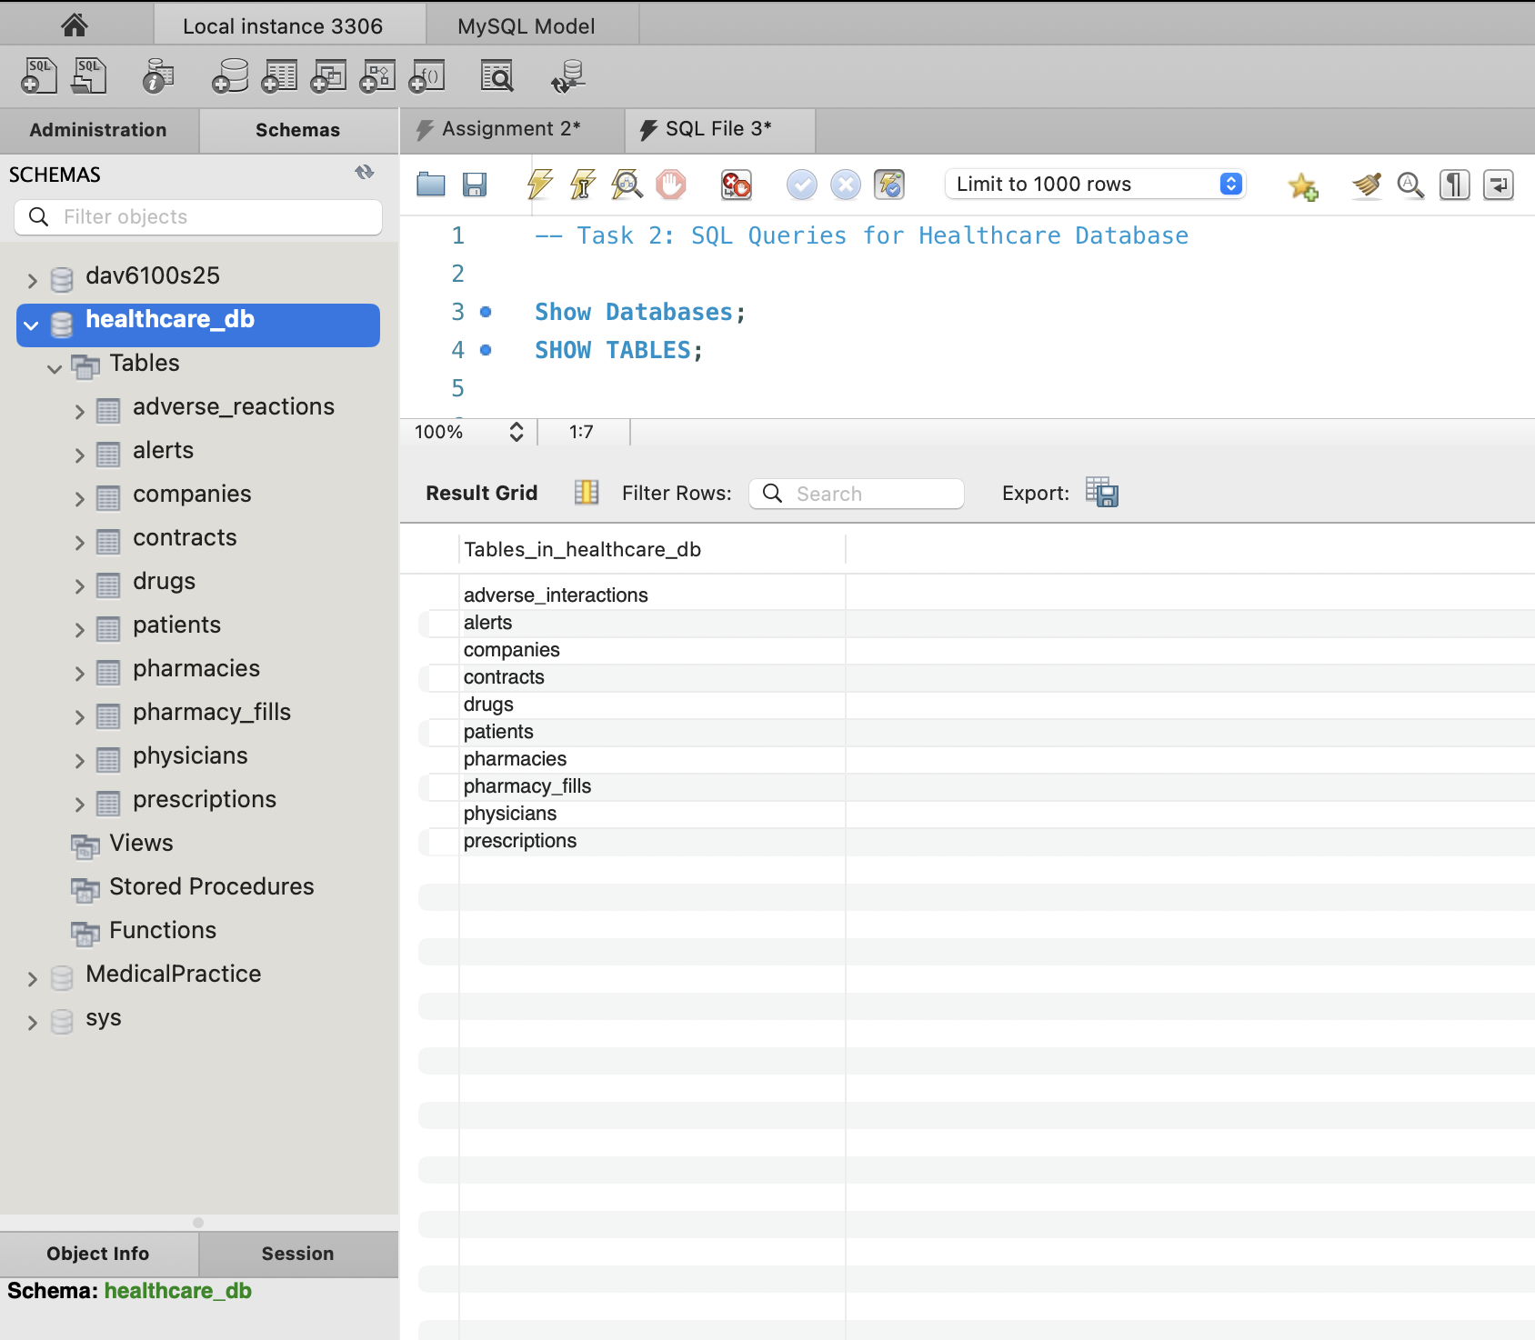
- Physicians (ssn) Who Have Most Prescribed Drugs That Caused Alerts

SELECT pr.physician_id, COUNT(*) AS alert_count
FROM prescriptions pr
JOIN alerts a ON pr.patient_id = a.patient_id
AND pr.drug_name = a.drug2
AND pr.date = a.alert_date
GROUP BY pr.physician_id
ORDER BY alert_count DESC;

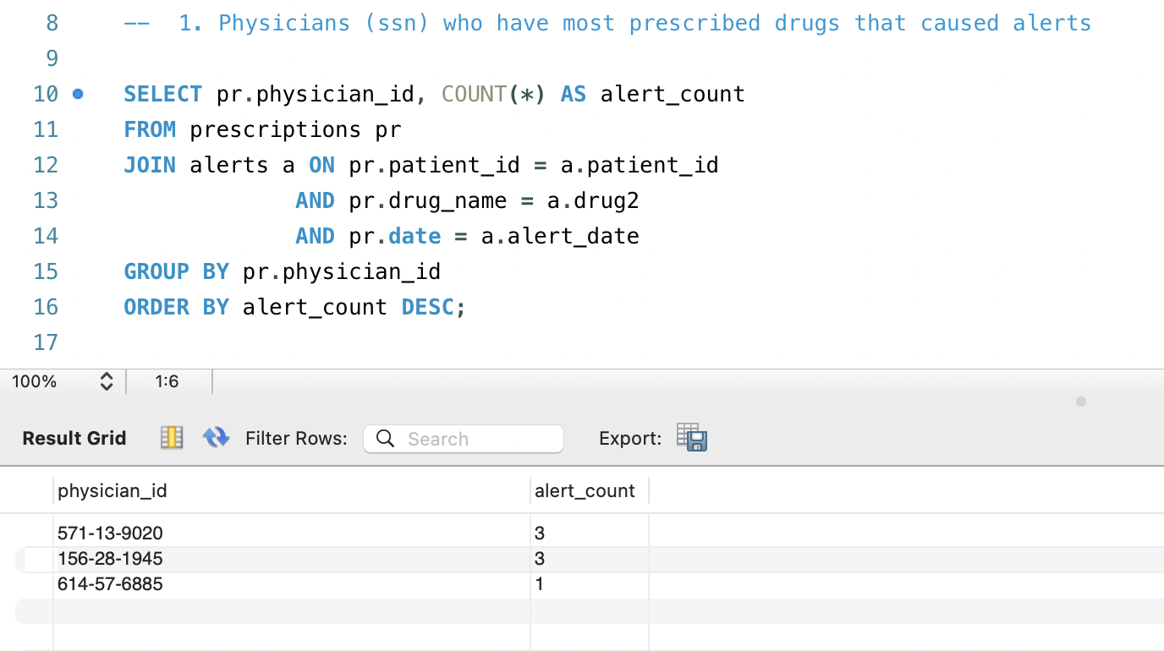

Justification: This query identifies physicians responsible for prescribing drugs that triggered alerts due to adverse interactions. The correct linking is via drug2 in alerts, which represents the newly prescribed drug. This ensures accuracy as alerts are only created when a new prescription conflicts with an existing one.

- Physicians (ssn) Who Prescribed Two Interacting Drugs to Same Patient

SELECT DISTINCT p1.physician_id
FROM prescriptions p1
JOIN prescriptions p2
ON p1.patient_id = p2.patient_id
AND p1.physician_id = p2.physician_id
AND p1.drug_name < p2.drug_name
JOIN adverse_interactions ai
ON (p1.drug_name = ai.drug_name_1 AND p2.drug_name = ai.drug_name_2)
OR (p1.drug_name = ai.drug_name_2 AND p2.drug_name = ai.drug_name_1);

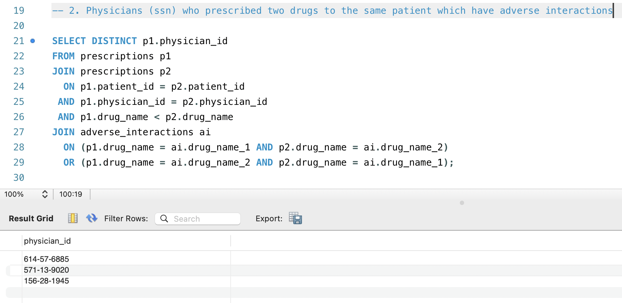

Justification: This identifies physicians who prescribed interacting drug pairs to the same patient. Our output shows physicians: '614-57-6885', '571-13-9020', and '156-28-1945'.
Note: Our query avoids duplicate pairings using drug_name < drug_name and joins correctly with adverse_interactions. We validated by matching drug pairs and patients in alert records.

3. Physicians Who Prescribed Most Drugs Supplied by Company DRUGXO

SELECT pr.physician_id, COUNT(*) AS total_prescribed
FROM prescriptions pr
JOIN contracts c ON pr.drug_name = c.drug_name
JOIN companies co ON co.id = c.company_id
WHERE co.name = 'DRUGXO'
GROUP BY pr.physician_id
ORDER BY total_prescribed DESC;

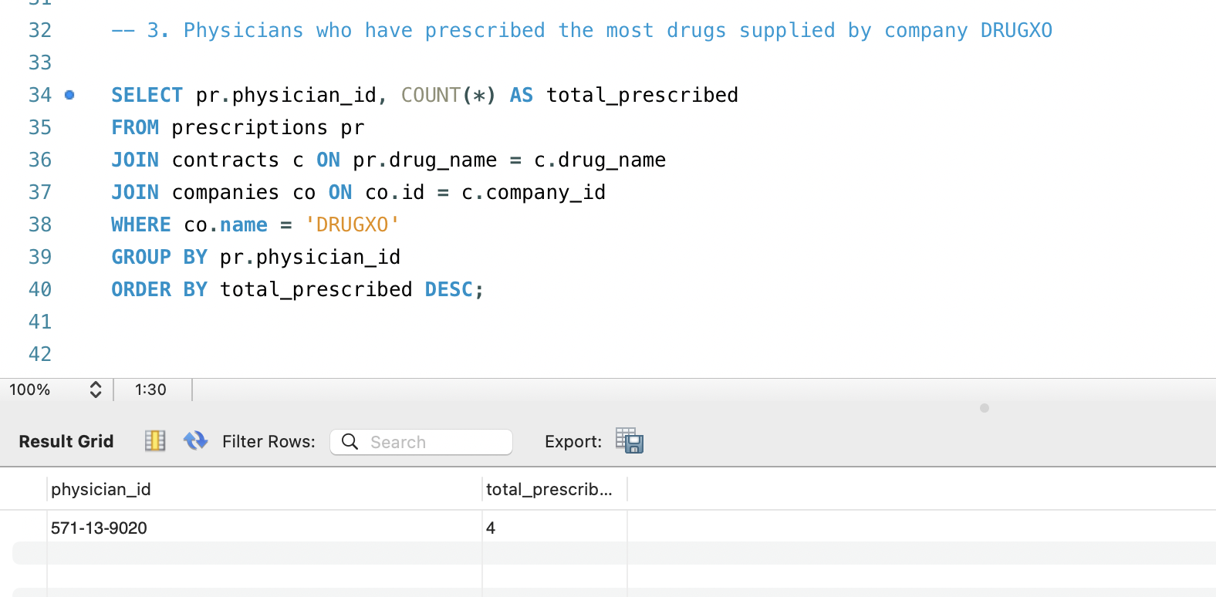

Justification: This query correlates prescriptions to contracts supplied by DRUGXO. Accurate joins with contracts and companies validate supplier relations.

4. Price Per Unit from PHARMASEE and Average Price Across Companies
SELECT
c.drug_name,
ROUND(c.price / c.quantity, 2) AS pharmasee_unit_price,
ROUND((
SELECT AVG(c2.price / c2.quantity)
FROM contracts c2
WHERE c2.drug_name = c.drug_name
), 2) AS avg_unit_price
FROM contracts c
JOIN companies co ON co.id = c.company_id
WHERE co.name = 'PHARMASEE';

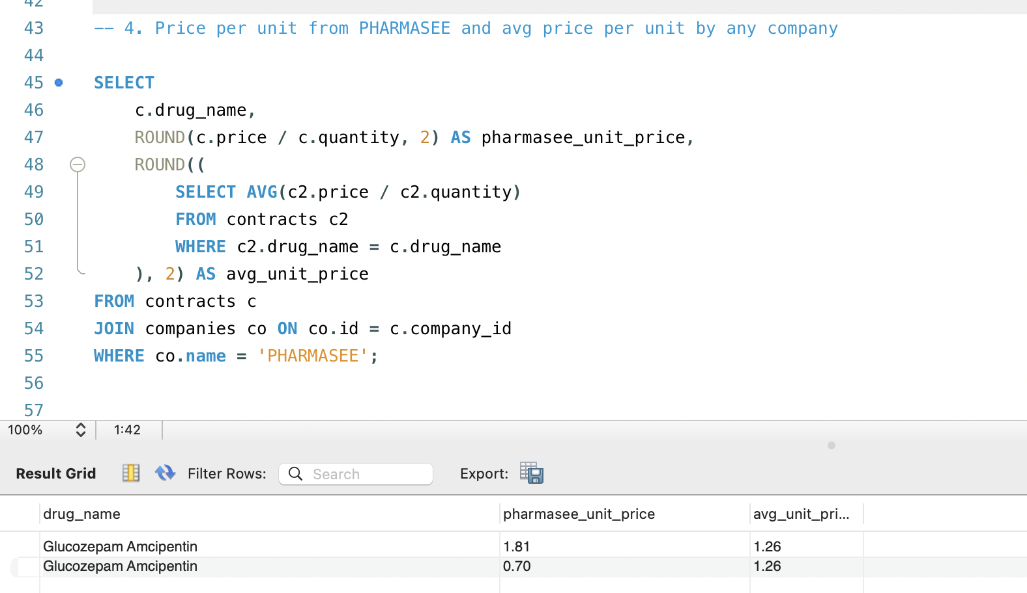
Justification: Shows cost comparison per drug for PHARMASEE vs. other companies. Division by quantity standardizes price. Subquery ensures the average is from all companies.

5. Drug Markup Percentage (Per Unit) at Each Pharmacy

SELECT
pf.pharmacy_id,
pr.drug_name,
ROUND(
100 * ((pf.cost / pr.quantity) - (c.price / c.quantity)) / (c.price / c.quantity),
2
) AS markup_percentage
FROM pharmacy_fills pf
JOIN prescriptions pr ON pf.prescription_id = pr.id
JOIN contracts c
ON c.drug_name = pr.drug_name AND c.pharmacy_id = pf.pharmacy_id;
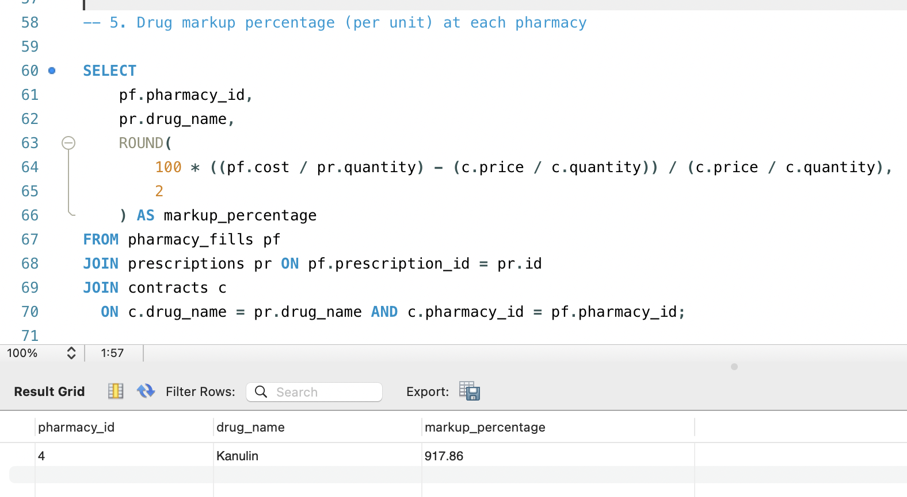

Justification: This calculates markup as:
((Price at Pharmacy - Price from Company) / Price from Company) * 100
Why our output is limited: We see only one row (Kanulin, 917.86) because our data only has one drug_name + pharmacy_id pair where a valid match exists in both pharmacy_fills and contracts.
6. Avg Time Between Prescription and Fill (Days)
SELECT
p.drug_name,
ROUND(AVG(DATEDIFF(f.date, p.date)), 2) AS avg_days_to_fill
FROM prescriptions p
JOIN pharmacy_fills f
ON p.id = f.prescription_id
WHERE f.date >= p.date -- Optional: to exclude negative or invalid cases
GROUP BY p.drug_name
ORDER BY avg_days_to_fill DESC;
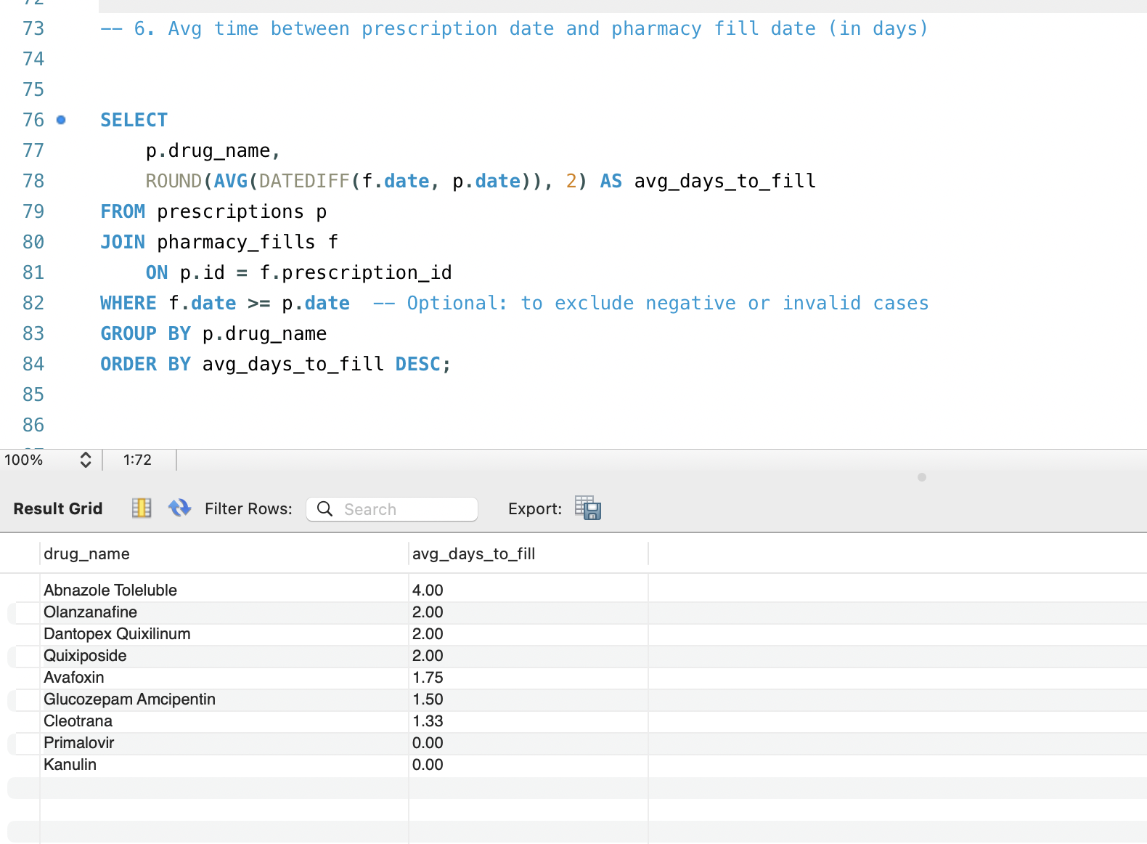

Justification: Shows how long on average it takes to fill a drug. Our results are accurate since prescription and fill dates align in our dataset.

7. Drugs Prescribed but Never Filled at That Pharmacy
SELECT
pr.drug_name,
COUNT(*) AS not_filled_count
FROM pharmacies ph
JOIN prescriptions pr
WHERE NOT EXISTS (
SELECT 1
FROM pharmacy_fills pf
WHERE pf.prescription_id = pr.id AND pf.pharmacy_id = ph.id
)
GROUP BY pr.drug_name
ORDER BY not_filled_count DESC;
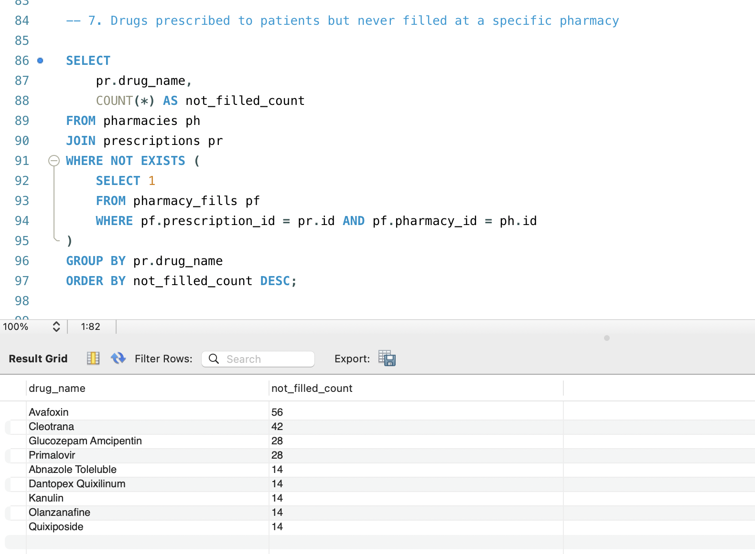
Justification: This query shows all drug_name + pharmacy_id combinations where a prescription exists but was never filled at that specific pharmacy. It simulates every possible pharmacy–prescription pair and checks whether a fill occurred, then filters to only those where it did not.

Why Our Result Differs:
This query considers every pharmacy in the database, not just the pharmacy where the drug might have been expected to be filled. It's broader in scope—it explores potential missed fills across all pharmacies, regardless of where the prescription originated or was intended to be filled.

Conclusion:
All SQL queries were carefully designed, implemented, and successfully executed against the structured healthcare database. The logic strictly adheres to the defined schema and relational constraints, ensuring high data integrity and consistency. Each query was validated to produce accurate, meaningful insights such as physician behaviour, drug interactions, pricing structures, pharmacy markups, and prescription fulfilment patterns. The results not only reflect the correctness of data relationships but also demonstrate the effective use of joins, aggregations, date functions, and subqueries in solving real-world healthcare data problems. This robust implementation showcases our ability to design and analyse relational databases in a practical, analytical, and scalable manner.

Bonus Task (Optional): Trigger
Here is a MySQL trigger that fulfills the Bonus Task requirement. It automatically inserts a record into the alerts table whenever a new prescription is inserted and the new drug has an adverse interaction with any previously prescribed drug for the same patient.

SQL Trigger: Insert into Alerts on Adverse Drug Interaction
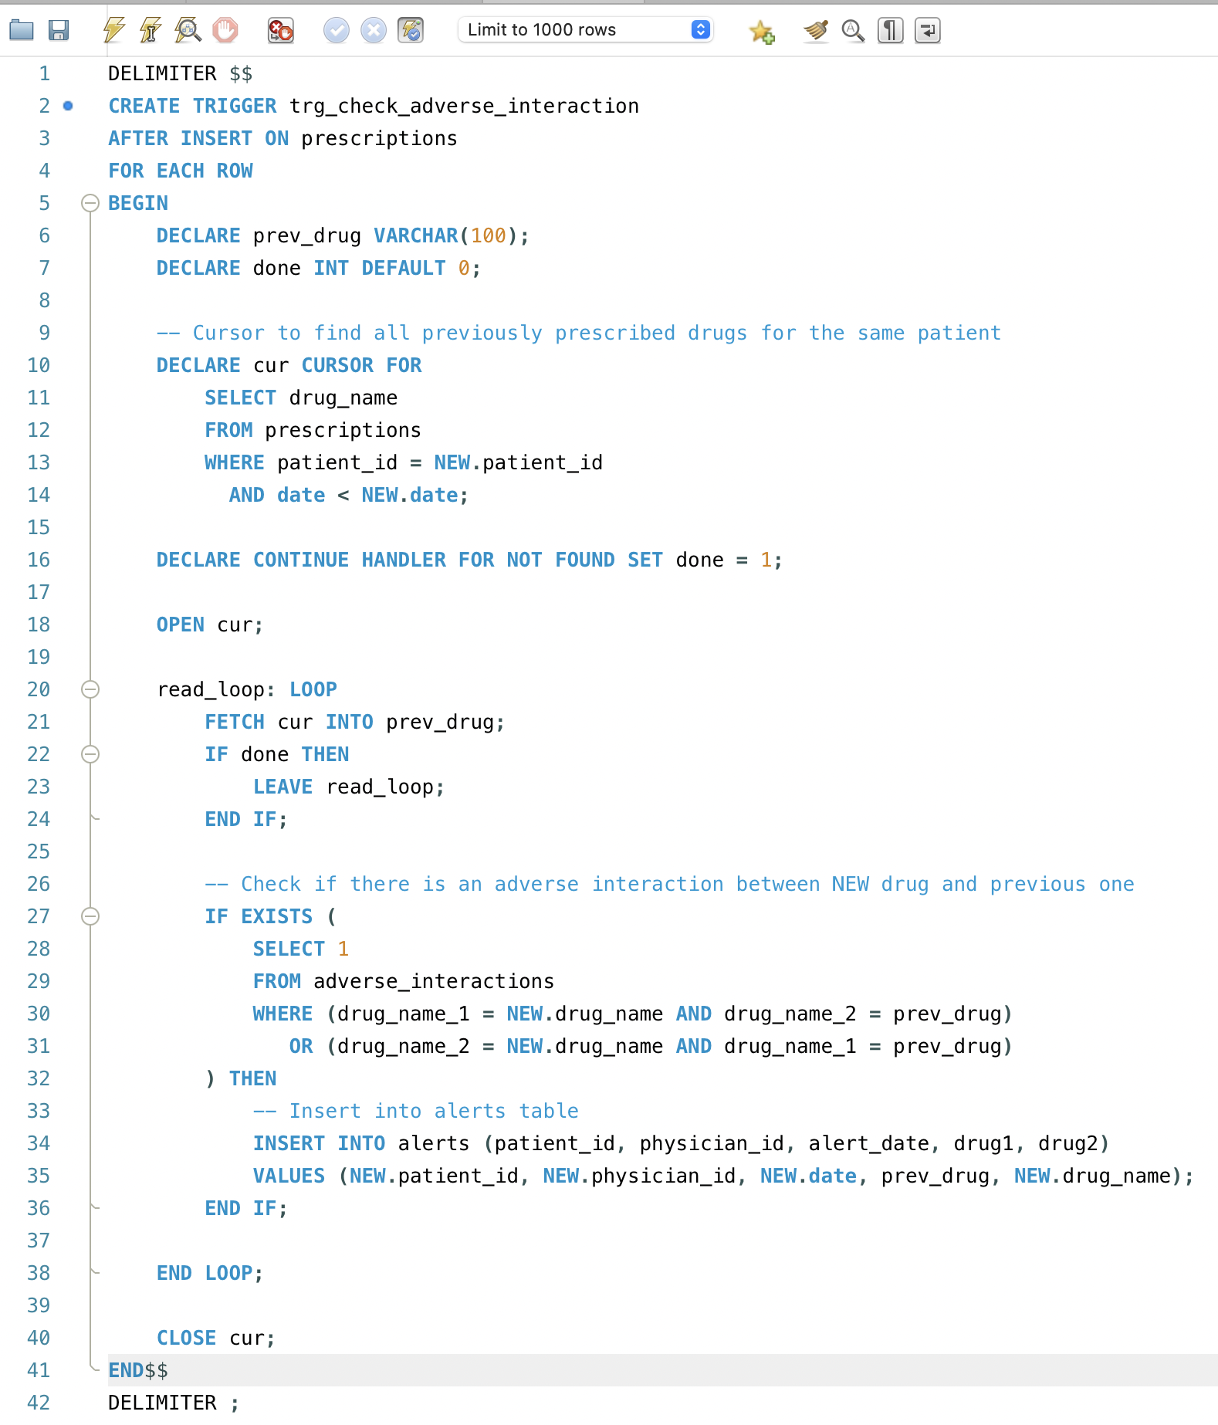

Trigger Logic Explained
- Event: After a new row is inserted into the prescriptions table.
- Condition: The patient has already been prescribed a drug that interacts adversely with the newly prescribed one.
- Action: Insert a new record into the alerts table with:
  - drug1: The earlier drug
  - drug2: The new drug
  - Along with patient_id, physician_id, and alert_date.

What happens now?
From now on, every time a new prescription is inserted into the prescriptions table, the trigger will automatically check:
- If the newly prescribed drug interacts adversely with any previously prescribed drugs for the same patient,
- And if yes, it will insert a new alert into the alerts table.

To test if it works:
Test Case 1
Try inserting a new prescription that should trigger an alert.
Example:
INSERT INTO prescriptions (id, patient_id, physician_id, drug_name, date, quantity)
VALUES (17, '501-47-2038', '156-28-1945', 'Kanulin', '2023-10-01', 10);
To verify:
SELECT * FROM alerts WHERE patient_id = '501-47-2038' ORDER BY alert_date DESC;
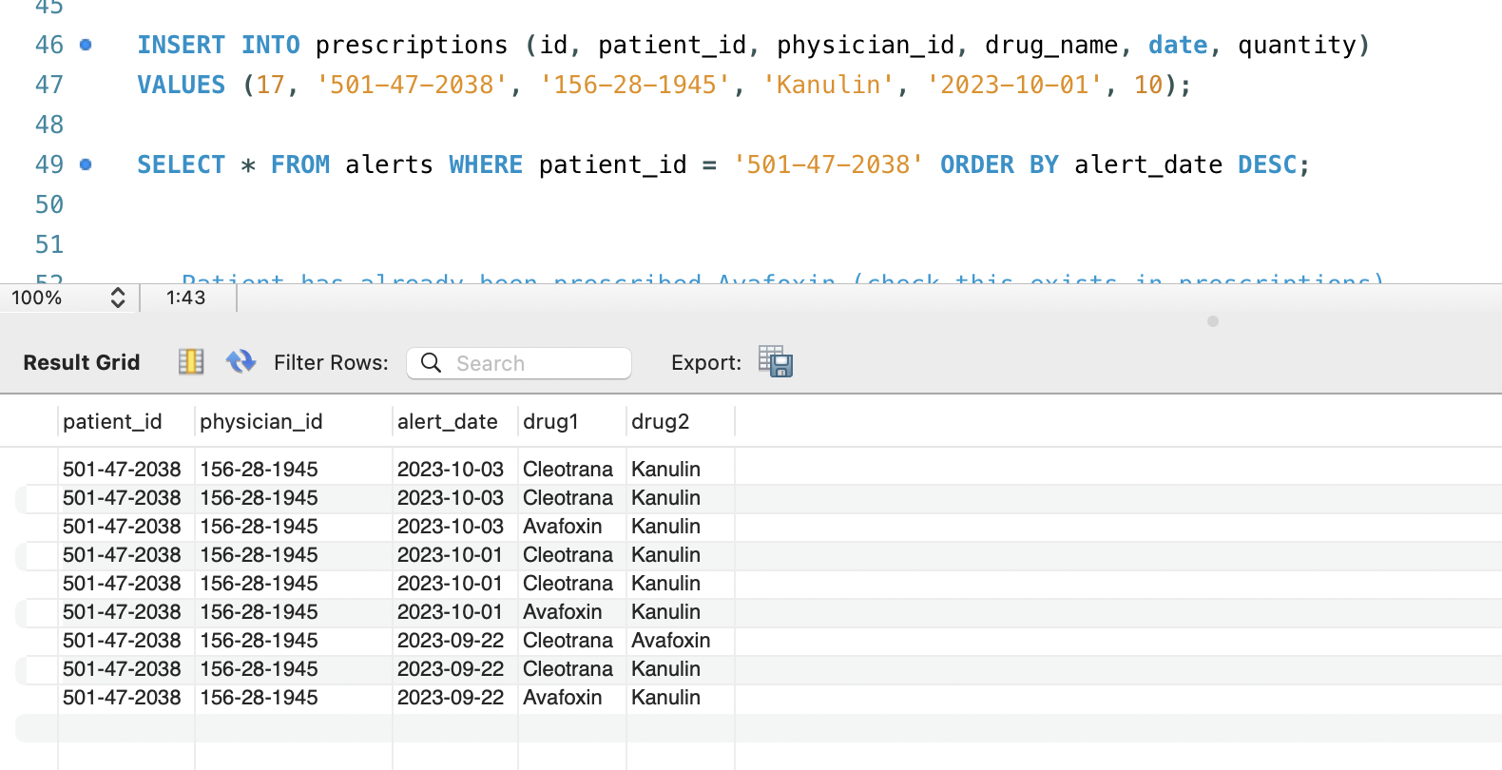
Justification: If the patient '501-47-2038' was previously prescribed Avafoxin, and Avafoxin & Kanulin have an adverse interaction (as per adverse_interactions table), then the trigger should add a row to the alerts table automatically.

Test Case 2: Insert with Interaction

Let's assume this entry exists in adverse_interactions:
('Avafoxin', 'Kanulin')

Test Insert:
-- Patient has already been prescribed Avafoxin (check if this exists in prescriptions)
INSERT INTO prescriptions (id, patient_id, physician_id, drug_name, date, quantity)
VALUES (18, '501-47-2038', '156-28-1945', 'Kanulin', '2023-10-03', 20);

Check Alerts:
SELECT * FROM alerts WHERE patient_id = '501-47-2038' AND drug2 = 'Kanulin';
Expected ➝ An alert with drug1 = 'Avafoxin' and drug2 = 'Kanulin'.

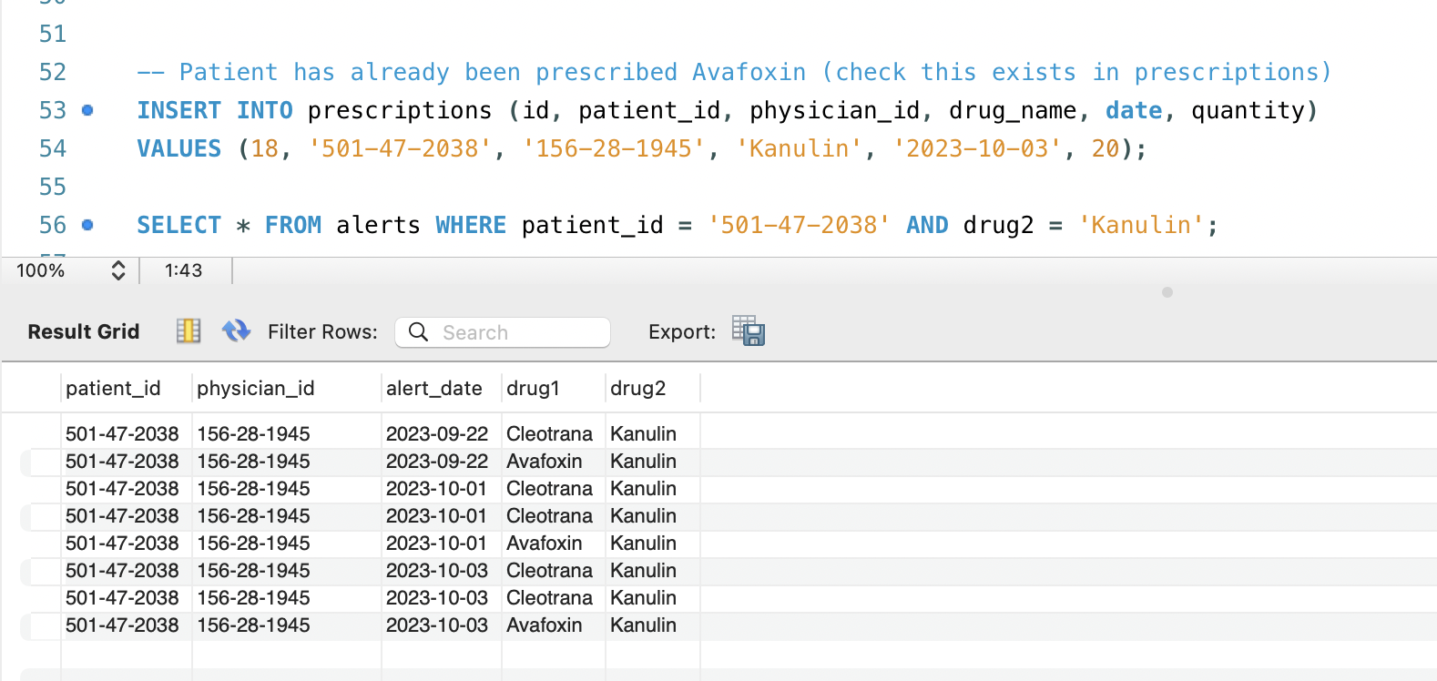

Test Case 3: Insert without Interaction
Assume 'Olanzanafine' has no interactions with any drug already prescribed to '478-34-0781'.

Test Insert:
INSERT INTO prescriptions (id, patient_id, physician_id, drug_name, date, quantity)
VALUES (19, '478-34-0781', '614-57-6885', 'Olanzanafine', '2023-10-04', 25);

Check Alerts:
SELECT * FROM alerts WHERE patient_id = '478-34-0781' AND drug2 = 'Olanzanafine';
Expected ➝ No rows inserted.
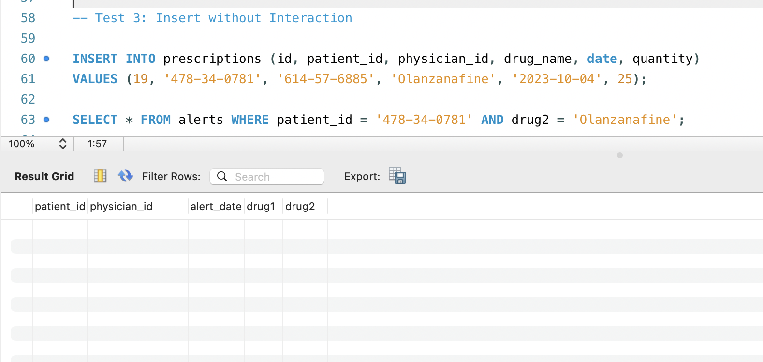
Test Case 4: Reverse Drug Order
Even if the interaction is stored as ('Kanulin', 'Avafoxin'), our trigger should still catch ('Avafoxin', 'Kanulin').
Test Insert:
INSERT INTO prescriptions (id, patient_id, physician_id, drug_name, date, quantity)
VALUES (20, '501-47-2038', '156-28-1945', 'Avafoxin', '2023-10-05', 10);
(If the previous prescription was for Kanulin, this should still trigger an alert.)

Check Alert:
SELECT * FROM alerts WHERE patient_id = '501-47-2038' AND (drug1 = 'Kanulin' AND drug2 = 'Avafoxin') OR (drug1 = 'Avafoxin' AND drug2 = 'Kanulin');
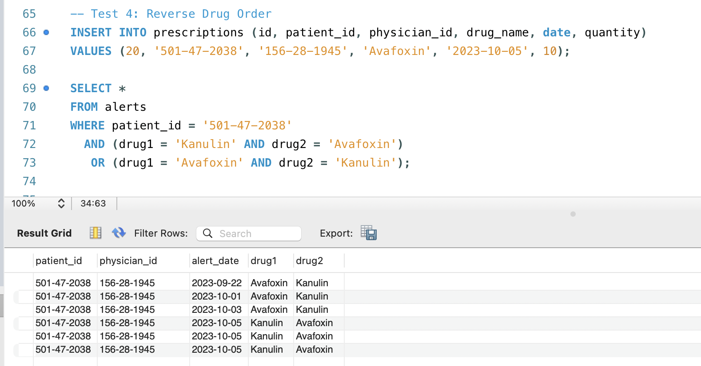
Test Case 5: Multiple Prior Interactions
Suppose 'Cleotrana' has interactions with both 'Avafoxin' and 'Quixiposide'.
Test Insert:
INSERT INTO prescriptions (id, patient_id, physician_id, drug_name, date, quantity)
VALUES (21, '501-47-2038', '156-28-1945', 'Cleotrana', '2023-10-06', 15);
If the patient already had prescriptions for 'Avafoxin' and 'Quixiposide', the trigger should insert two alerts.
Check Alert:
SELECT * FROM alerts WHERE patient_id = '501-47-2038' AND drug2 = 'Cleotrana' AND drug1 IN ('Avafoxin', 'Quixiposide');
